Radioactive Decay Practice Name: ________________________
Unit 10 – Geological History Date: _________ Period: _________

W.S. – Radioactive Decay Practice

Pre-Questions: Answer the following questions using the Radioactive Decay Data chart located on page one of your Handy Dandy Earth Science Reference Table.

1. What are the four radioactive isotopes listed in the reference table?

a.__________________________________ c. __________________________________

b. _________________________________ d. __________________________________

2. What is the decay product (daughter or disintegration) of the following radioactive isotopes?

a. Carbon-14 (¹⁴C) → ______________________________

b. Potasium-40 (⁴⁰K) → ____________________________

c. Uranium-238 (²³⁸U) → ___________________________

d. Rubidium-87 (⁸⁷Rb) → ___________________________

3. What is the half-life (in years) of the following radioactive isotopes (NOT in scientific notation)?

a. Carbon-14 _____________________________ c. Uranium-238 __________________________

b. Potasium-40 ___________________________ d. Rubidium-87 ___________________________

Discussion Questions:
1. What happens to the amount of Nitrogen-14 as the Carbon-14 decays? ______________________________

2. How old is a bone in which the Carbon-14 in it has undergone 3 half-lives? __________________________

3. What happens to the amount of unstable isotopes disintegrates into the stabile isotope? _________________

4. If a sample contains 25g of Carbon-14 and 175g of Nitrogen-14, how many half-lives has it undergone?

5. What percent of Carbon-14 is left after 5 half-lives?

6. If a 20g of Carbon-14 has a half-life of 5,700 years, what would be the half-life of a 40g sample? Why?

7. Which radioactive isotope would be best used in dating the following items?

a. A buried tree stump: ______________________________________
b. The oldest know rocks on Earth: _____________________________

8. Why would Carbon dating not be a useful way to date Coelophysis fossils? Use your ESRT!
Procedure:
1. Complete the following table which shows the process of decay of Carbon-14.
2. Plot the number of half-life vs ¹⁴C and ¹⁴N (Make sure to have a difference symbol for ¹⁴C and ¹⁴N)

Half-Life | Years | Atoms of ¹⁴C | Atoms of ¹⁴N
0 | 0 | 100,000 | 0
1 | 1 | 50,000 | 50,000
2
3
4
5
6
7
8

Number of Half-Life vs. ¹⁴C and ¹⁴N
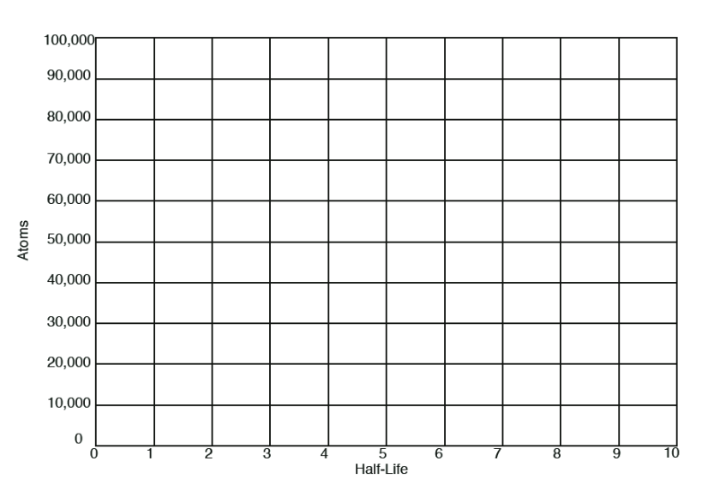

Key: ¹⁴C ¹⁴N

